Species distribution modeling shows decrease in suitable green junglefowl habitat

## Green Junglefowl (Gallus varius) (7936877492).jpg

**Name: Roelof de Vries**

**Student number: 1485121**

## Table of contents

Introduction 3

Methodology 4

Results 6

Discussion and conclusion 14

References 14

## Introduction

This report looks at the spatial distribution of Gallus varius, known in English as the green junglefowl. Initially, the species planned for this project was Gallus gallus domesticus (the chicken), but since that species would probably not give spatial data of wild ones, and most likely data of chickens in gardens or farms, it would not be possible to predict how their wild range of occurence would shift over time because they are mainly kept by humans. This led to the consideration of the wild ancestor, Gallus gallus (red junglefowl), but I did not manage to select for this species only in GBIF without also selecting subspecies (such as domesticus). Maybe it was possible, but for the sake of time I went ahead and chose the genus member Gallus varius.

Commonly (IUCN status: least concern) found on the islands of Indonesia, it is also introduced on the Cocos Keeling Islands. As its name suggests, it lives in the jungle habitat. ‘Found at altitudes of 0-2000m, it lives in subtropical/tropical lowland moist forest, shrubland and arable land, and has been seen flying from island to island in its native range, where it lives and breeds along coastal areas.’**1** Humans breed it in captivity and create a hybrid with chickens, the results is called the bekisar.

SDM will reveal where the species occurs and where it could potentially occur. In its native range, rain seasons occurs, so it should be used to rainfall. If the amount of annual rainfall changes in the future, as well as changes in temperature, it may impact the species distribution.

**Research question:**

How will the spatial distribution of Gallus varius change over time in a future scenario, regarding the impacts of climate change?

**Hypothesis**

Due to shifts in temperature and rainfall, Gallus varius will disperse from its native range as new habitat becomes suitable for the species.

Because it has natural dispersal capabilities, it may be able to adapt to a changing climate.

## Methodology

First occurrence data will be downloaded from GBIF. The occurrence data will be checked for errors using ArcGIS. Environmental variables will be downloaded from the worldclim database (version1.4). HadGEM2-ES will be selected, using the bioclimatic variables from rcp45. After that, R will be used to crop the environmental variables relevant to the area of interest (AOI). The bioclimatic variables will be tested against one another to check for autocorrelation. The variables that show too much correlation will be removed. Afterwards, a VIF test will be performed to see if more variables need to be removed. Maxent is used to perform SDM using the cropped environmental data and species occurrences, making predictive maps for the future with only the suitable bioclimatic variables. The output will show predictions for suitable habitat that Gallus varius may migrate towards.

**Occurence data**

The selected data consisted only out of human observations.

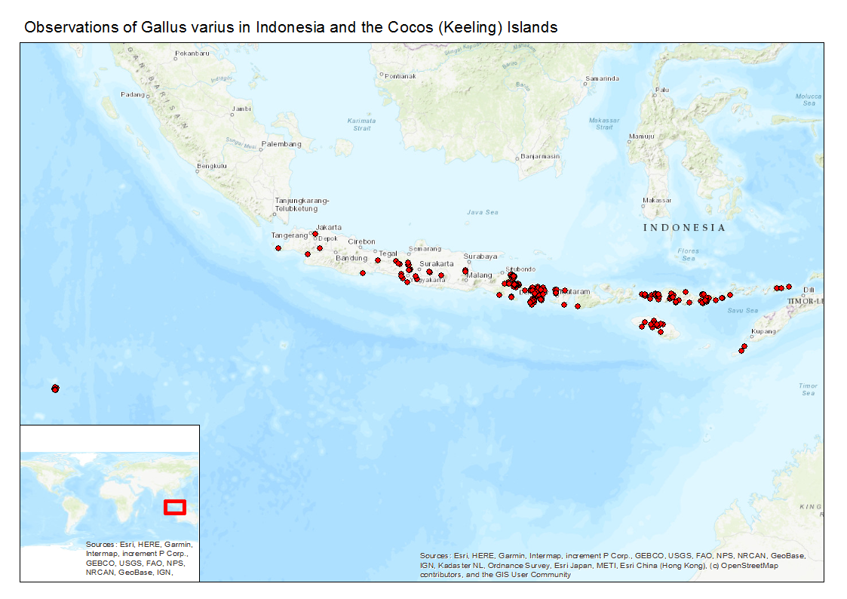Some data points seem to have been shifted a bit. The occurrence data around the Cocos Keeling Islands seems to be in the sea, but follows the shape of the island. (FIGURE?) Therefore these shifted points will still be included in the analysis. The species occurs where it is expected to be, on Indonesia, where it is endemic. Since the data shows that it is on the Indonesian islands, it properly reflects the ecological niche. No corrections were applied to the data, because it is assumed every point in the sea is caused by a mismatch by the program in coordinate systems or something of that kind of error.

**Environmental data**

Before testing for autocorrelation, the variables that were selected were BIO1, BIO4, BIO8, BIO9, BIO10, BIO11, BIO12, BIO16, BIO17, BIO18 and BIO19. Variables relating to quarters were selected instead of months due to the interest in what role the rain season plays in the species distribution. After testing for autocorrelation, the variables that remained were BIO2, BIO4, BIO6, BIO16, BIO17, BIO18 and BIO19. BIO2 and BIO6 were first not considered but after testing for correlation they were deemed suitable because they remained after weeding out the correlated variables. Testing for multicollinearity revealed that no extra variables had to be taken out.

**Model settings**

The bioclimatic variables BIO2, BIO4, BIO6, BIO16, BIO17, BIO18 and BIO19 were selected in Maxent. The species occurrence data as well as the environmental layers of the world (Present_WLD) were used. Present_WLD was used for the final output of Maxent because Present_AOI showed a wrong correlation between temperature and species distribution (meaning that colder temperatures would be better, leading to areas for the green junglefowl being deemed suitable that were better if they were colder). Five replicates were made.

## Results

The summarized output of the five runs was analyzed. The mean AUC was 0.988, meaning the model was a good fit.

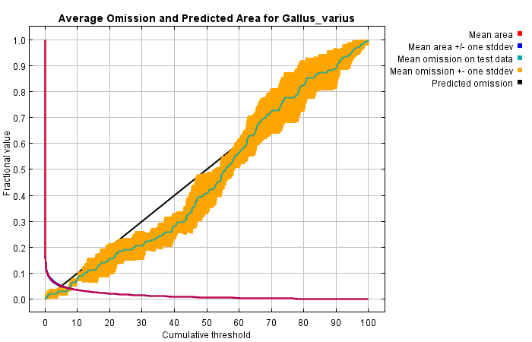

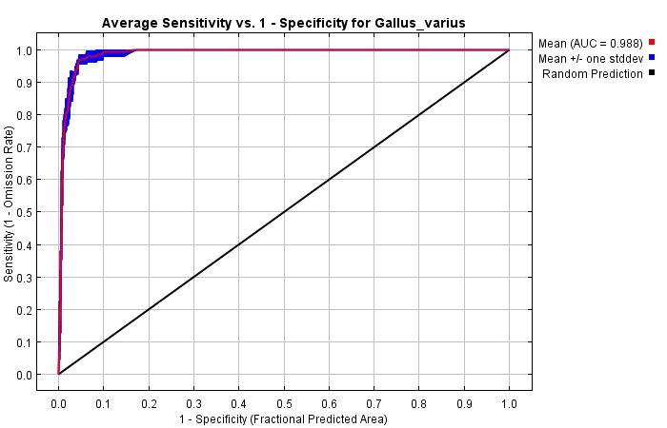

Below is the output of the response curves. The first set shows the contribution of each variable to the presence of the species in the Maxent model while all other environmental variables remain at their average sample value.  
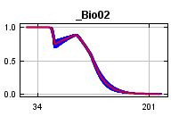 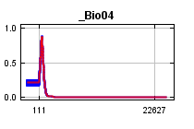 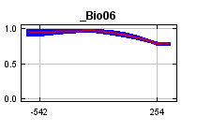 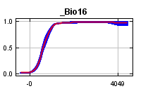 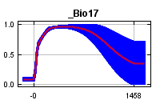 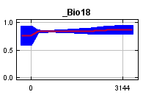 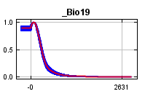  
  
But below here it shows the contribution of each variable to the presence of the species in the Maxent model using only that variable without the values of the others.  
  
  
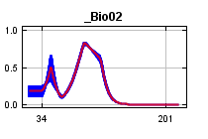 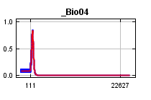 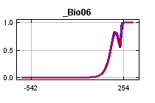 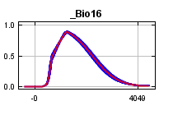 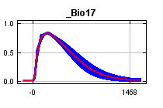 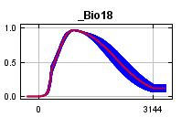 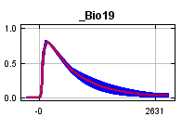

The following table gives the estimates of the contributions of the environmental variables to the model.

|  |  |  |
| --- | --- | --- |
| **Variable** | **Percent contribution** | **Permutation importance** |
| _Bio04 | 49.4 | 85.8 |
| _Bio16 | 20.3 | 2.4 |
| _Bio19 | 12.1 | 5.3 |
| _Bio17 | 8.6 | 2.2 |
| _Bio02 | 5.1 | 3.3 |
| _Bio18 | 3.7 | 0.1 |
| _Bio06 | 0.8 | 0.9 |

The jackknife test results are below. Bio4 (temperature seasonality) seems to be the most important bioclimatic variable.  
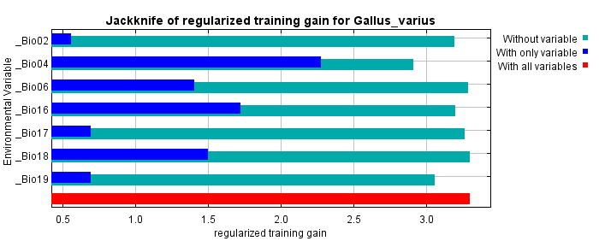  
  
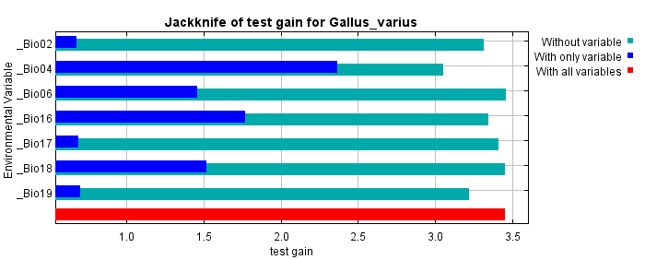  
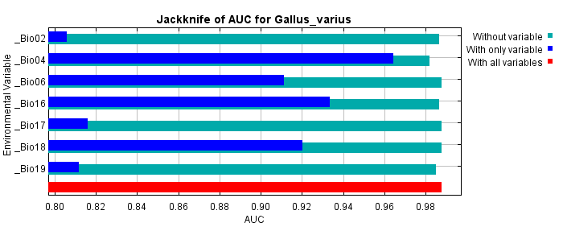

The prediction for the present (Present_WLD, figure below) show suitable habitat around the equator in the middle of the Americas, south America and Africa. It also shows suitable habitat further north in south-east Asia. That is not surprising seeing as how the fellow genus members of Gallus varius, such as G. gallus, G. Lafayettii and G. Sonneratii are all species that widely occur in south-east Asia. It makes sense that G. Varius would be able to live in areas that are more or less the same, because they are closely related. It may be possible for G. Varius to live in those areas, but it will need to be introduced by humans because its dispersal capabilities only allow it to fly from island to island. It may be possible to further spread in south-east Asia, but it may face competition from its fellow genus members, limiting its spread.

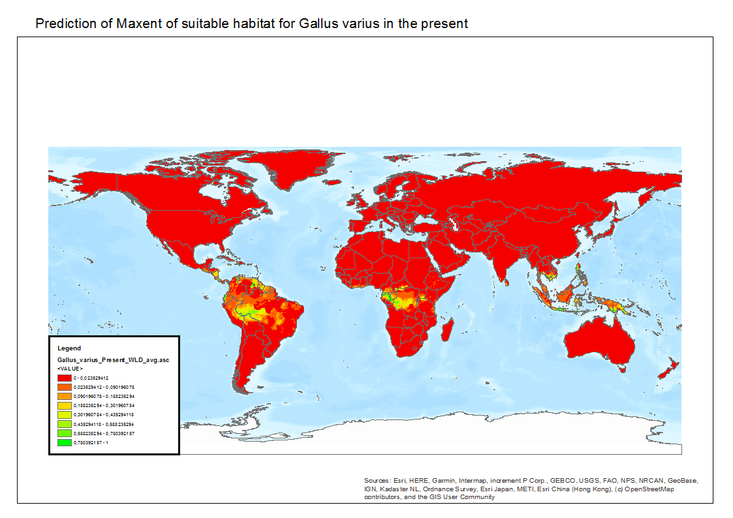

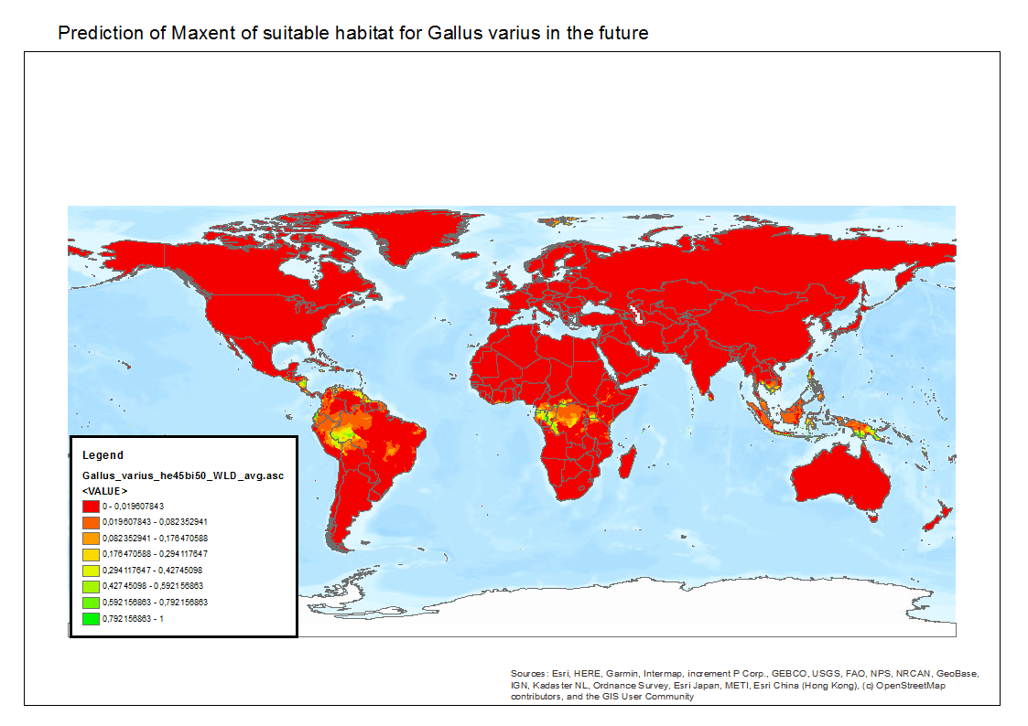

The future data (he45bi50_WLD, figure above) shows that every predicted suitable habitat has shrunk, and that there is a little bit of area that may become suitable around Svalbard (yellow color). This is highly unlikely seeing as it is too far north for a jungle species. It also predicts that the area where it currently occurs will shrink. Below are two figures that show the decrease in predicted suitable habitat. It predicts a small shrink of most of the area it deems suitable in the present in the rest of south-east Asia as well. If G. Varius is really under threat by climate change (the results show it loses a chunk of its habitat), humans will have to help it to migrate to suitable habitats, which exist around the globe according to Maxent.

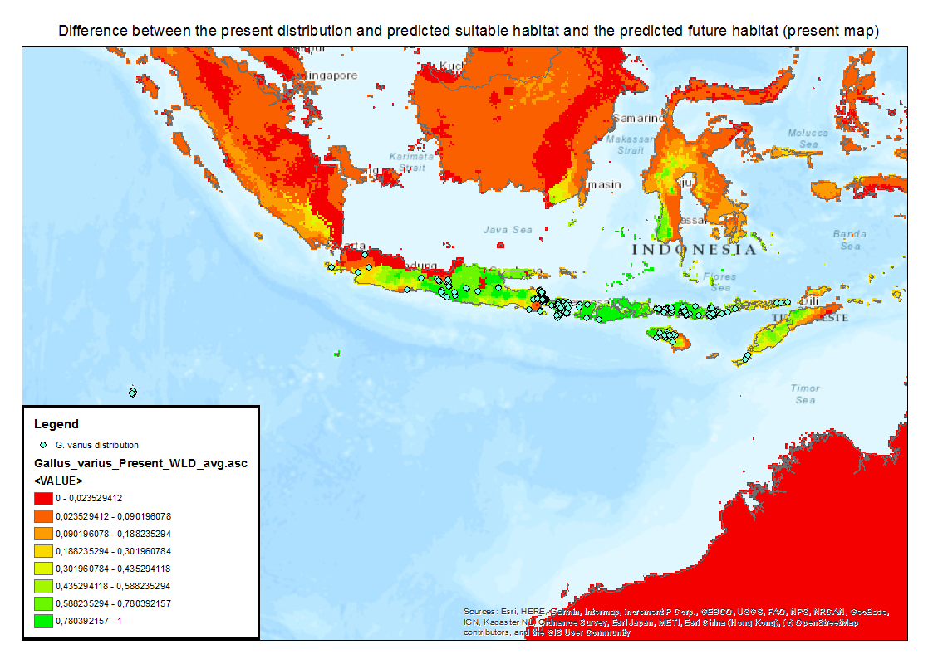

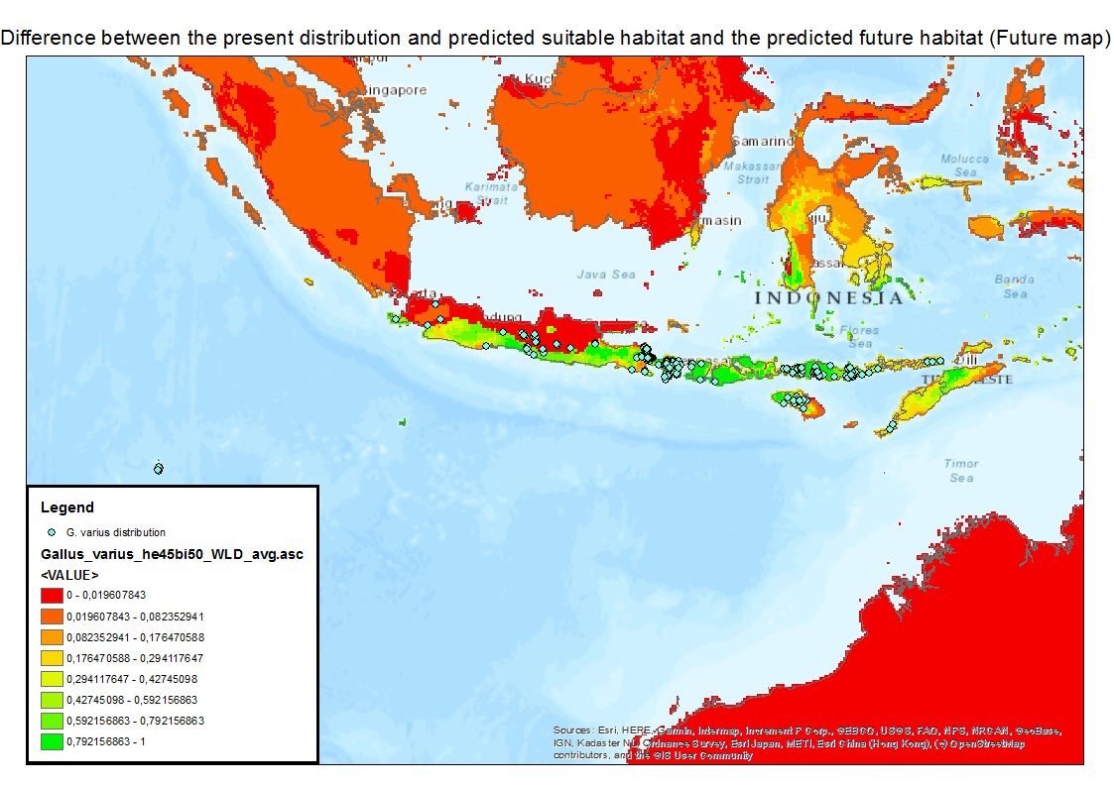

## Discussion & conclusion

When looking at the map at a later time in ArcGIS, the occurrence data of the Cocos Keeling Islands seems to be properly on the map again. Because it was first assumed the data points shifted a little bit but were still correct, every data point was used in this study. However, now some points are in the sea and these were previously not taken out because it was assumed they were actually supposed to be on land but were in the sea due to a mismatch by the program. Now these points were used for the study anyway but it probably did not impact the results that much.

The predictions show suitable habitat for G. Varius across the globe around the equator. This makes sense as it is a jungle bird, and Maxent managed to predict possible habitats quite well. It also assigned temperature seasonality as the most important bioclimatic variable that impacts the probability of G. Varius occurrence. It was expected that G. Varius would gain habitat as well as lose it, so it could shift spatially in a favourable direction. However, it seems that the opposite is the case, and that it habitat shrinks. But there is possibility for the bird to live in other areas, but it will probably have to depend on humans to get there. However, SDM does not take biotic factors into account. Areas Maxent deems suitable may not be suitable in reality due to predators, disease or maybe something else like competition. Further research will be needed to investigate the suitability of the predicted habitats for Gallus varius to disperse into, but for now the bird seems to be doing fine.

## References

Front page picture: By Bernard DUPONT from FRANCE - Green Junglefowl (Gallus varius), CC BY-SA 2.0, <https://commons.wikimedia.org/w/index.php?curid=39583869>

General information about the green junglefowl:

<https://en.wikipedia.org/wiki/Green_junglefowl>

GBIF data: GBIF.org (03 December 2019) GBIF Occurrence Download https://doi.org/10.15468/dl.x2f1ug